IdeAir: Internet of Things-Based System for Indoor Air Quality Control

Gleiston Guerrero-Ulloa1,2 [0000-0001-5990-2357], Alex Andrango-Catota1 [0000-0002-0965-7522], Martín Abad-Alay1 [0000-0002-4585-2878], Miguel J. Hornos2 [0000-0001-5722-9816] and Carlos Rodríguez-Domínguez2 [0000-0001-5626-3115].

1 Faculty of Engineering Science, State Technical University of Quevedo, 120501 Los Ríos, Ecuador

{gguerrero, alex.andrango2016, martin.abad2016}@uteq.edu.ec

2 Higher Technical School of Computer and Telecommunications Engineering,  
University of Granada, 18071 Granada, Spain  
gleiston@correo.ugr.es, (mhornos, carlosrodriguez}@ugr.es

**Abstract.** The burning of fossil fuels by cars and household appliances, which make people's lives easier, causes air quality to deteriorate. Heaters, which help low-income people to live in better conditions, can cause their death. Many solutions to this social problem have been proposed; however, all of them suffer from some disadvantage that makes it impossible to implement them in households with limited economic resources. In this work we propose the design of IdeAir, a low-cost system based on Internet of Things (IoT) to monitor air quality that aims to reduce the disadvantages of existing systems. It captures data on harmful gases and determines their concentrations, issuing alarms and notifications according to their concentration levels. Its development has been carried out following the Test Driven Development Methodology for IoT-based Systems (TDDM4IoTS), which, together with the tool used (based on this methodology) for the automation of the development of the system, facilitated the work of the developers. Preliminary results show a high acceptance by potential users.

**Keywords:** Internet of Things, Development Methodology, Development Tool, Microcontrollers, Air Quality.

1. Introduction

Air quality is measured by the amount of toxic gases present in the environment. Gases, such as ozone (O3) at the earth's surface, particulate matter (PM), nitrogen dioxide (NO2), carbon monoxide (CO), carbon dioxide (CO2), ammonia (NH3), sulphur dioxide (SO2) and benzene (C6 H6), are the main pollutants in the environment. These gases are produced by the burning of fossil fuels in vehicles, refineries, thermoelectric power generators, and industries, and even appliances that are used for heating and cooling [1] and even appliances used in the home, such as space heaters to heat the environment and water for daily activities. These gases, above certain concentration levels, cause potential harm to human health, and in the worst cases, death. This is especially problematic in populations at high altitudes, where there is a low concentration of oxygen. Concern to prevent these pollution-related deaths worldwide has prompted the WHO (World Health Organisation) to update the indicators for air quality in order to improve this universal right [2].

Space heaters are used to condition the room temperature in homes in cold climates. These appliances, being fuelled by fossil fuels, emit gases, such as CO, which, due to their characteristics (odourless, invisible, tasteless and non-irritating to the eyes), are hazardous [4]. In fact, CO is considered to be the *silent killer*. This problem, and the consequences of the possible misuse of heaters, have concerned several governments, such as those of Argentina [5] and Ecuador [6].

Bommi et al. [7] propose a very important solution to monitor and try to solve the pollution problem. However, due to the investment required, it would not be feasible to implement it in households using space heaters. Another work on air quality monitoring is presented by Zhou et al. [8]who present a system that issues messages to the user when pollution levels exceed thresholds. In addition, to prevent a serious event, the system can turn on a fan, which would clearly be insufficient in an enclosed space, such as inside a house.

As a contribution to reduce the number of people suffering from poisoning by hazardous gases, such as CO, CO2, NO2, NH3 and C6 H6, this paper proposes an IoT-based system (IoTS) that is able to detect these gases indoors, and make appropriate decisions. The system issues alerts based on the detected levels of concentration of the pollutant gases and helps to restore indoor air quality. It can therefore be seen as a system for maintaining ideal air, hence its name: IdeAir. After its implementation, a technical demonstration of its execution was carried out in the city of Quito, the capital of Ecuador, which has a cold climate and is located at 2850 metres above sea level, where there have been several deaths due to problems with heating systems [3].

The main motivation for the development of this IoTS is to provide a reliable solution with a feasible and low-cost implementation to address the social problem described above. Another motivation is to perform an initial validation of the development methodology proposed by Guerrero-Ulloa et al. [9] as it is a new methodology, and one of the few methodologies specifically designed for IoTS development.

The remainder of this document is organised as follows: Section 2 presents the related work. The section 3 describes the proposed system, as well as the development methodology followed and the results obtained by applying each of the phases of this methodology. Finally, the section 4 section summarises the conclusions and future work.

1. Related work

The world is concerned about air pollution and its fatal consequences. This is reflected in the fact that the WHO has issued new guidelines for controlling air pollution, considering particulate matter (PM) from 2.5µm size upwards. [2]. Moreover, the scientific community has presented some work to help alleviate the consequences of air pollution and improve air quality.

Considering that vulnerable people often spend a lot of time in indoor environments, where contamination is higher than in outdoor environments [10]solutions have been presented for these spaces. Bommi et al. [7] aim to control air pollution by reducing the toxicity of gases produced by combustion through a physico-chemical process that generates oxygen.

In the line of pollution monitoring, one can consider the work of Liu, et al. [11]which consists of monitoring CO2 and PM2.5 , among other parameters. In the field of pollutant monitoring there is also AirSensEUR, which consists of a plug-and-play interoperable sensor node, designed as an open multisensor platform whose investment is around 1000 euros. [12].

Taştan & Gökozan [13] propose *e-nose*, a mobile real-time air quality monitoring system. It is enabled to measure various air parameters, such as CO2 , CO, NO2 , PM10 , temperature and humidity. However, the only way to alert the user about dangerous pollution levels is through notifications sent to the mobile application. Another work is that of Azma et al. [14]which provides air quality readings using low-cost sensors.

Although all the works reviewed provide solutions to help prevent people from environmental conditions harmful to their health, each of them has some characteristic that makes it impractical to be implemented in low-income households. In the case of the systems presented respectively by Bommi et al. [7] and by Liu et al. [11]their main disadvantage is the high investment required. In addition, the laser used to obtain oxygen in the first one has to be activated manually when the CO value exceeds a threshold value, while the second system is intended for smart buildings. On the other hand, the analysed systems, except for Bommi et al. [7]do not have adequate mechanisms to try to improve air quality. Another disadvantage of all the reviewed works [7], [11]–[14] is the limitation of the means in which the notifications are reproduced, as they are only reproduced through the mobile application. In the system proposed by Azma et al. [14]in the system proposed by Azma et al., sending notifications via email is not very effective in emergency situations.

As an attempt to counteract the disadvantages of the aforementioned systems, we have designed and developed a proof-of-concept IdeAir, which is a low-cost IoTS. IdeAir consists of: (1) a device to be deployed inside the home, (2) a mobile application for configuring the device, viewing real-time data and receiving alerts on pollution levels, and (3) a web application that, in addition to having the same functions as the mobile application, serves to visualise reports of the data captured by the system and additional information from IdeAir.

1. Proposed system

The proposed IdeAir system, in addition to providing information on air quality levels, alerts users in many ways, depending on the detected levels of air pollution. For this work, four levels of CO have been considered to determine air quality, as shown in Table 1. Table 1. In addition, for each level, the system displays the corresponding message on its LCD screen.

**Table 1.** Air quality levels.

| **Level** | **Quality** | **Concentration (ppm)** | **Notifications (light)** | **Actions** |
| --- | --- | --- | --- | --- |
| 1 | Good | ≤ 350 | Green | No sound and no performance. |
|  | Moderate | (350, 500] | Blue | Intermittent beeping sound. |
|  | Baja | (500, 800] | Orange | Medium and constant sound,  opens the window. |
|  | Mala | > 800 | Red | Loud and constant sound,  opens the window,  switch on the fan,  notification in the mobile app. |

As shown in the Table 1table, the highest level (4) is the most dangerous. The table also shows the alerts and actions that have been implemented in IdeAir for the four air quality levels considered.

IdeAir is an IoTS developed to support low-income families who may be at risk from the use of space heaters or other similar equipment.

* 1. Development methodology

IdeAir was developed as a proof of concept, to verify its functionality and effectiveness. The development methodology used was TDDM4IoTS, which specifies 4 roles to be played by the members of the project team [9]. In our case, the role of *project facilitator* was played by an expert in IoTS development. The *development team* consisted of 2 developers with experience in IoTS and traditional information systems (IS) development. The role of *advisor* was played alternatively by the two developers, depending on the domain of each one on the topic to be applied (hardware, web applications, mobile applications, web services, database, etc.). The advantage of this role play is to try to balance the mastery of the topics needed in IoTS development. The role of *users/clients* was played by people living in the city of Quito. Therefore, real user requirements were taken into account.

Communication between project members was 90% telematic, as they were geographically dispersed. Meetings were held weekly by videoconference, and consultations and advice, as well as the delivery of software material, were provided by telematic means. GitHub was used for software version control. Hardware was provided through sporadic meetings with the project facilitator, or was directly ordered from suppliers via their respective online purchasing platform.

An attempt was made to carry out the activities involved in the 11 phases of development of the methodology, in their order, as specified in TDDM4IoTS [9]. The execution of the activities and their results are shown in the following subsection.

* 1. Results of applying TDDM4IoTS to this case study

In the following, the work carried out in each of the development phases specified by TDDM4IoTS is detailed. [9]in order to obtain the final product.

### Preliminary analysis . Although the IoTS developed in this project is a system that can be considered relatively small, it is also necessary to perform the preliminary analysis phase in order to have a solid starting point. This phase, which allows to know the initial conditions of the environment in which the system will be deployed, as well as to determine whether it is feasible to meet the requirements demanded by the user, involves the following activities:

#### Requirements Analysis . It is necessary to have a safe indoor environment. Poor installation, daily use, or sudden breakdowns of heaters can cause irregular amounts of toxic gases to be produced due to poor combustion. When it comes to the home environment, these problems can cause damage to the health of its inhabitants, and even death. The user needs to stay at home resting, doing housework and/or work (in times of pandemic, for example). In order to reassure users, the concentration of harmful gases should be determined from the concentration of PM2,5 and PM10 , and the user should be made aware as soon as possible of the danger to which he is exposed, so that he can take appropriate precautions, if necessary.

Formal and informal interviews with a group of people in the city of Quito-Ecuador were used to determine the existing problem in the households of the people involved. Thus, the requirements for IdeAir were established, among which are the following:

* Detect harmful gases, in particular: CO, O3 , CO2 , NO2 , NH3 and C6 H6 .
* Alert the user who is inside the home.
* Alerting the user who is away from home.
* To cause the detected gases to be dissipated into the environment and/or to be vented to the outside.

Once the system requirements are known, it can be determined how to satisfy them through an appropriate solution.

Technology analysis. All the points raised by the methodology in this activity were answered positively. In other words, the necessary hardware resources were available. These resources are cheap and effective in fulfilling their functions. The software tools for the configuration of the IoTS hardware being presented are available to all and free of charge, such as the Arduino IDE and the TDDT4IoTS (Test-Driven Development Tool for IoTS). [15].

This activity of the methodology compared the different options for both hardware and software components. Among the indicators that determined which ones to use for this project were: popularity of use, integration between hardware and software, cost, functionalities, ease of use and mastery by the development team.

The tools selected for the development of this case study were: Apache Netbeans IDE, for the development of the web application; TDDT4IoTS, for the design and generation of models and code for both applications (web and mobile), as well as for the design of the hardware and generation of the code for its configuration (save code on the Arduino board); Arduino IDE, to compile and complete the editing of the programming code for the hardware configuration; Android Studio, to complete, compile and generate the *apk* file of the application for the Android operating system; MySQL, as a database; and WebHost, as a web and database server.

Analysis of the environment. The device will be deployed in a low-income household. It will be installed in a strategic location near a source of electricity. In these pandemic times, families were forced to contract internet services for students' homework, and even for adults' teleworking, so they have this service via WiFi. IdeAir will use this resource to send data to the cloud in real time, using web services. The user will be notified the instant the gas concentration changes. As the environment is silent, one way of alerting users present in the home will be through sounds, in addition to notifications on mobiles that install the app.

Feasibility analysis. The study carried out determined the feasibility of IdeAir's development in the three aspects considered:

* Technical: The competencies of the development team were considered sufficient, given their previous experience. The technologies necessary for the development of the system exist in the market and are easy to acquire. And the estimated development time was considered adequate by the users.
* Economical: The components to be used are low-cost and available on the local market.
* Operational: Once the system is deployed, the user does not need any technical knowledge to keep the system running.

### Design of the technology layer. In this phase, the architecture of the IdeAir system was first obtained, which consists of 3 layers. The top layer is the user interaction layer, consisting of the web and mobile applications. The lower layer is the sensors and actuators (physical layer). This layer is responsible for controlling the environment. And as an intermediate layer is the layer of connectivity, processing and storage of information. In this layer is the WebHost service, used to send data in real time to be stored in the MySQL database and be displayed in web and mobile applications.

The **Fig. 1** shows the design of the device (corresponding to the physical layer) to detect the level of air quality and act appropriately (according to its configuration) to alert the inhabitants of the house and watch over their health when the air quality is not adequate. This diagram was realised using the TDDT4IoTS [9]. Its components are (see **Fig. 1**): (1) Arduino Uno board, configured to capture the data emitted by the MQ135 and MQ7 sensors, as well as to give the commands to the actuators; (2) MQ135 sensor, to detect levels of CO2 , C6 H6,  NH3 and NO2 ; (3) fans, to expel polluted air; (4) DHT11 sensor, to measure the temperature and humidity of the environment; (5) MQ7 sensor, to detect CO; (6) ESP3286 NodeMCU, development board to control the DHT11 sensor and for internet connectivity; (7) active buzzer, for audible notifications; (8) LEDs, for light notifications; (9) Servomotors, to open and close the window ; and (10) LCD display, to report ambient air quality.

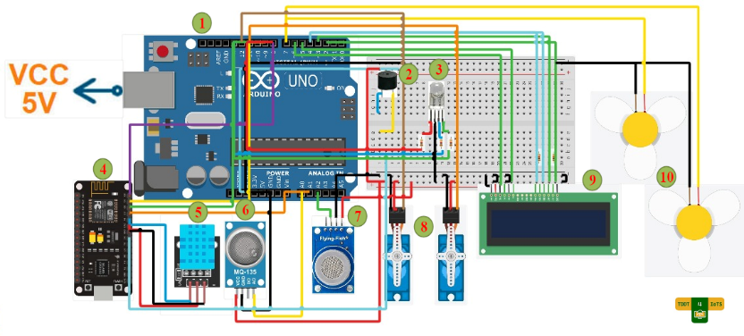

**Fig. 1.** IdeAir device design.

### Detailed requirements analysis . For the detailed requirements analysis, we used the extended use cases [16]were used for the detailed requirements analysis, as recommended by TDDM4IoTS [9]. The use cases have proved to be a very clear tool for collecting the functional requirements of the system, as expressed by the users. [17]. By doing a thorough analysis of each use case, and using TDDT4IoTS correctly, the development of an IoTS will be easier.

### Model generation , testing, and software. In these 3 phases of TDDM4IoTS, the TDDT4IoTS development tool was used. [15]. This is a tool that is in its first version, and is able to generate even the web application, including its preliminary graphical interface, from the use cases. It also allows the design of IoT devices and automatically generates the software required for their configuration and operation (currently with support for Arduino). At the moment, TDDT4IoTS does not generate the mobile app. Therefore, the software for the user interfaces of the IdeAir mobile app (front-end) was created by the developers in its entirety.

Regarding the web application, TDDTIoTS uses the model-view-controller pattern to generate source code from the class diagram. In addition, part of the business logic is transformed into classes to generate and publish the RESTful web services, which will be used to execute the basic operations or CRUD (create, read, update, delete) with the database.

### Refinement and adaptation of models, software and tests. During model refinement, certain methods were added, such as constructors and other methods not specified in the use cases, as well as a class to specify air quality reference levels.

The figure shows part of the software architecture (the class diagram), after being generated by TDDT4IoTS and Fig. 2 shows part of the software architecture (the class diagram), after being generated by TDDT4IoTS and refined for IdeAir software generation and testing. In addition, some methods specified in the class diagrams had to be implemented by the developers, as their business logic could not be automatically generated from the use cases.

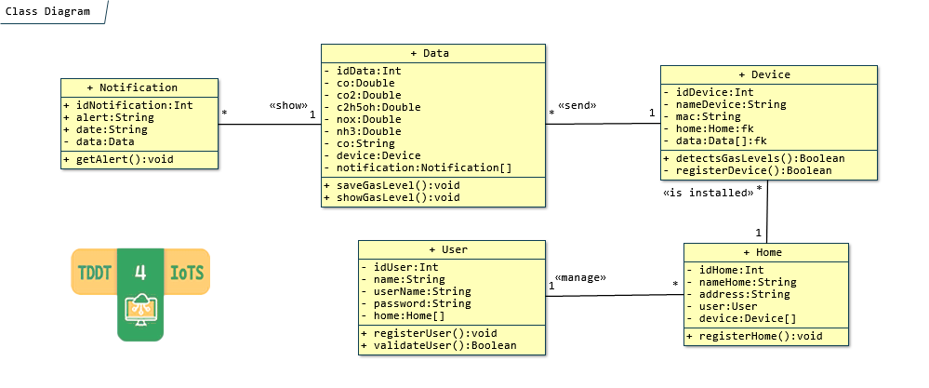

**Fig. 2.** IdeAir refined class diagram.

The automatically generated tests were refined and adapted to the needs of the end users. Integration tests were written by the developers in the detailed requirements analysis phase, and executed in the deployment to verify compliance. To test the correct functioning of the device before deployment, the environment was contaminated by generating appropriate gases, basically to test the capture and delivery of data in real time.

### Hardware and software deployment. The IdeAir device was deployed in a mock-up of a room simulating a real room, in order to prototype the operation of the system. In it, low-power servomotors were used, which are not sufficient to drive a real window. With this proof of concept, the authors believe that there is sufficient evidence to determine that this system meets the requirements set by the customer.

The web application is deployed on a server of the affiliation institution of some of the authors, within the subdomain *applications[1]* .

On the other hand, as described above, the mobile application allows registering the IdeAir device(s) for control, monitoring real-time data capture, and receiving notifications when gas levels are harmful to health, in addition to common operations such as registering as a user, logging in, and displaying information about the system. Some screenshots of the Fig. 3 screenshots of the mobile application are shown.

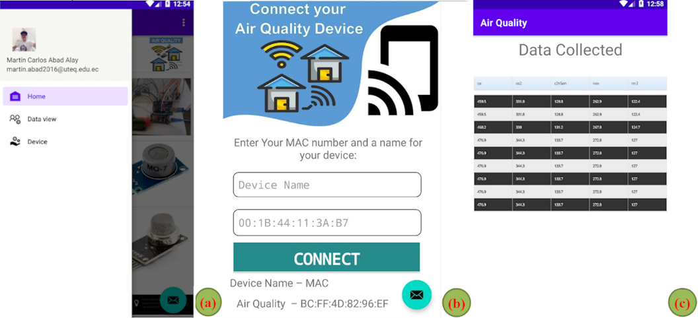

**Fig. 3.** Screenshots of the mobile application.

When the user has authenticated in the mobile application, he/she can access his/her information and the options to view devices and view the captured data, as shown in the Fig. 3(a). If you do not have registered devices, you can do so from the *Device* option and you will be presented with the screen shown in (b). Fig. 3(b). If you have registered an IdeAir device, you will be able to monitor the environments in which they are installed, and you will also be able to know in real time the data that the device is capturing and sending to the server, as shown in (c). Fig. 3(c).

1. Conclusions and future work

The implementation of a proof of concept of the IdeAir system has been presented, which makes it possible to determine the level of indoor air quality and to act and alert people when the level of toxicity is dangerous. The use of web services and a WebHost server makes it possible to know in real time the environmental data captured by IdeAir. In testing IdeAir, users commented that they found listening to the alarm and seeing the light notifications in the room more useful for alerting them to toxicity levels in the air than the notifications on the mobile app.

Following the TDDM4IoTS methodology made the developers more orderly in carrying out IoTS development activities. In addition, using the TDDT4IoTS tool helped them to be more productive. The code generated by the tool was used in its entirety.

As future work, we plan to continue improving the TDDT4IoTS tool, especially in terms of generating more code and generating the interfaces for the mobile application, both for Android and iOS. In addition, after evaluating its functions as a proof of concept, a prototype of the IdeAir system will be developed and deployed to test its operation in a real home.

References

1. Ezeonyejiaku, C., Okoye, C., Ezeonyejiaku, N., Obiakor, M.: Air Quality in Nigerian Urban Environments: A Comprehensive Assessment of Gaseous Pollutants and Particle Concentrations, Current Applied Science Technology 22(5), (2021).
2. World Health Organization: WHO Global Air Quality Guidelines. Particulate Matter (PM2.5 and PM10), Ozone, Nitrogen Dioxide, Sulfur Dioxide and Carbon Monoxide, (2021), https://apps.who.int/iris/bitstream/handle/10665/345329/9789240034228-eng.pdf, last accessed 2022/03/26.
3. Rodríguez, A.: A Bad Heater Caused a Tragedy in the Comité del Pueblo. Five Members of a Family Died, El Comercio - Actualidad (Un Calefón en Mal Estado Provocó una Tragedia en el Comité del Pueblo. Cinco Miembros de una Familia Murieron, El Comercio – Actualidad), <https://www.elcomercio.com/actualidad/quito/intoxicacion-monoxido-carbono-muerte-quito.html>, last acceded 2022/03/17.
4. Gazis A., Katsiri, E.: Smart Home IoT Sensors: Principles and Applications A Review of Low-Cost and Low-Power Solutions, International Journal on Engineering Technologies and Informatics 2(1), 2021.
5. Instantaneous Heaters are the Main Cause of Carbon Monoxide Poisoning : Civil Defence (Los Calefones Instantáneos son la Principal Causa Intoxicación por Monóxido de Carbono : Defensa Civil), https://www.mendoza.gov.ar/defensacivil/noticias/los-calefones-instantaneos-son-la-principal-causa-intoxicacion-por-monoxido-de-carbono/, last accessed 2022/03/14.
6. National Risk and Emergency Management Service (Servicio Nacional de Gestión de Riesgos y Emergencias): SGR Advises on the Use of Space Heaters (SGR Aconseja Sobre el Uso de Calefones), https://www.gestionderiesgos.gob.ec/sgr-aconseja-sobre-el-uso-de-calefones/, last accessed 2022/03/15.
7. Bommi, R. M., Monika, V., ArockiaKoncy, A. A., Patra, C.: A Surveillance Smart System for Air Pollution Monitoring and Management. In Lecture Notes on Data Engineering and Communications Technologies, pp. 1407-1418. Springer, Cham (2019).
8. Zhou, M., Abdulghani, A. M., Imran, A. M., Abbasi, Q. H.: Internet of Things (IoT) Enabled Smart Indoor Air Quality Monitoring System. In ACM International Conference Proceeding Series, pp. 89–93. ACM, New York (2020).
9. Guerrero-Ulloa, G., Hornos, M. J., Rodríguez-Domínguez, C.: TDDM4IoTS: A Test-Driven Development Methodology for Internet of Things (IoT)-Based Systems, Communications in Computer and Information Science, 1193, 41–55 (2020).
10. Shrestha, P. M. *et al.*: Impact of Outdoor Air Pollution on Indoor Air Quality in Low-Income Homes during Wildfire Seasons", *Int. J. Environ. Res. Public Heal. 2019, Vol. 16, Page 3535*, ISSN: 1660-4601, vol. 16, no. 19, p. 3535, Sep. 2019, DOI: 10.3390/IJERPH1619353535.
11. Liu, Z., Wang, G., Zhao, L., Yang, G.: Multi-Points Indoor Air Quality Monitoring Based on Internet of Things, IEEE Access 9, 70479–70492 (2021).
12. Kotsev, A., Schade, S., Craglia, M., Gerboles, M., Spinelle, L., Signorini, M.: Next Generation Air Quality Platform: Openness and Interoperability for the Internet of Things, Sensors, 16(3), 403 (2016).
13. Taştan, M., Gökozan, H.: Real-Time Monitoring of Indoor Air Quality with Internet of Things-Based E-Nose, Applied Sciences (Switzerland) 9(16), 3435 (2019).
14. Azma Zakaria, N., Zainal Abidin, Z., Harum, N., Chen Hau, L., Salih Ali, N., Azni Jafar, F.: Wireless Internet of Things-Based Air Quality Device for Smart Pollution Monitoring, International Journal of Advanced Computer Science and Applications (9)11, 65–69 (2018).
15. Guerrero-Ulloa, G., Carvajal-Suárez, D., Brito-Casanova, G., Pachay-Espinoza, A., Hornos, J.M., Rodríguez-Domínguez, C.: Test-Driven Development Tool for IoT-based System, Aug. 2021. https://aplicaciones.uteq.edu.ec/tddm4iots/ (accessed Apr. 02, 2022).
16. Usländer, T., Batz, T.: How to Analyse User Requirements for Service-Oriented Environmental Information Systems. In Advances in Information and Communication Technology, vol. 359, pp. 161–168 (2022).
17. Dörr, J., Kerkow, D., von Knethen, A., Paech, B.: Eliciting Efficiency Requirements with Use Cases. In 9th International Workshop on Requirements Engineering: Foundation for Software Quality (REFSQ), vol. 8, pp. 23–32 (2003).

1. https://aplicaciones.uteq.edu.ec/ideair/)